AGENDA

Ordinary Meeting of Council

Tuesday 28 November 2023 at 6:00 pm

Notice is hereby given of the Ordinary Council Meeting

to be held in the Council Chamber

Administration Building

48 Old Perth Road, Bassendean WA 6054

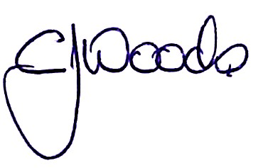
Cameron Woods
CHIEF EXECUTIVE OFFICER

23 November 2023

Meeting Information

Recording and Live-streaming

All participation in the meeting, except for confidential business, will be audio recorded and live-streamed on the Town’s website. The live stream will be archived and made available on the Town’s website after the meeting.

Conduct at meetings

The Town is committed to ensuring our Council Meetings are a safe work environment, free of risks to the health and wellbeing of Elected Members, Officers and our community. Any person attending is required to be respectful, courteous and have due regard for individual rights and differences. Individuals may be asked to leave should their conduct adversely affect the health and safety of others.

By attending this meeting, you agree to abide by these conditions.

For any questions regarding the Ordinary Council meeting or any item presented in the agenda, please contact the Town of Bassendean at:
mail@bassendean.wa.gov.au.

Tune in to live streaming from the comfort of your own home by going to:
Town of Bassendean Council - YouTube

or if you miss it live, go to:
https://www.youtube.com/channel/UC46mMs3D7vmHuO0ePibihhg

Council Role

Each Report presented will identify what Council’s Role is in the item

Advocacy | When the Council advocates on its own behalf or on behalf of its community to another level of government/body/agency.
Executive | The substantial direction setting and oversight role of the Council. e.g. adopting plans and reports, accepting tenders, setting and amending budgets.
Legislative | Includes adopting local laws, local planning schemes and policies.
Review | When the Council operates as a review authority on decisions made by Officers for appeal purposes.
Quasi-Judicial | When the Council determines an application/matter that directly affects a person’s rights and interests. The judicial character arises from the obligation to abide by the principles of natural justice. Examples of Quasi-Judicial authority include development applications, building permits, applications for other permits/licences (eg under Health Act, Dog Act or Local Laws) and other decisions that may be subject to review by the State Administrative Tribunal.
Information | For the Council/Committee to note.

Table of Contents

1 Declaration Of Opening; Acknowledgment of Country; Acknowledgment of Visitors; Disclaimer 7
2 Announcements by The Presiding Person Without Discussion 7
3 Attendances, Apologies and Applications for Leave of Absence 7
4 Declarations of Interest 7
5 Presentations or Deputations 7
6 Statements by Members of the Public 7
7 Questions from Members of the Public 8
8 Petitions 8
9 Confirmation of Minutes 8
10 Business Deferred from Previous Meeting 8
11 External Committee Reports and Updates 9
11.1 External Committee Reports and Updates 9
12 Officer Reports 10
12.1 Management arrangements for Hyde Retirement Village 10
12.2 Incentives for Trees of Significance 14
12.3 Application for Development Approval - Proposed Works & Change of Use - 1 (Lot 50) Surrey Street, Bassendean 17
12.4 RFT 05/2023 Provision of Arboricultural Services 28
12.5 Differential Rates Refund Policy Review 30
12.6 Use of Town Facility - Reserve 21150 (BIC Reserve) 34
12.7 Accounts Paid - October 2023 38
12.8 Proposed Carport - 104 (Lot 174) Ivanhoe Street, Eden Hill 40
12.9 Memorandum of Understanding with Swan Districts Football Club 46
12.10 Draft amended Local Planning Policy 2 - Sustainable Development 48
12.11 Contract Variation - RFT 04/2023 Supply and Installation of a Bore at Ashfield Reserve 51
12.12 Bassendean Local Emergency Management Committee Meeting - 14 November 2023 54
13 Motions of which Previous Notice has been given 56
14 Announcements of Notices of Motion for the next meeting 56
15 Urgent Business 56
16 Confidential Business 56
17 Closure 56

1 Declaration Of Opening; Acknowledgment of Country; Acknowledgment of Visitors; Disclaimer

Acknowledgement of Traditional Owners

The Town of Bassendean acknowledges the past and present traditional owners of the land on which we gather to conduct this meeting, and pays its respects to their Elders, both past and present.

2 Announcements by The Presiding Person Without Discussion

3 Attendances, Apologies and Applications for Leave of Absence

4 Declarations of Interest

5 Presentations or Deputations

6 Statements by Members of the Public

Public statement time will be limited to two minutes per person.

Members of the public are encouraged to submit their statements in advance by completing the relevant form:
Online Form - Public Statement Time » Town of Bassendean

Please complete this form and submit it to the Town’s Chief Executive Officer by no later than 12noon on the day of the meeting.

It should be noted that comments are recorded and live streamed via YouTube, and that there is no protection from legal action being taken against you, should it arise from your comments delivered at the meeting.

7 Questions from Members of the Public

15 minutes will be allocated for questions by members of the public any question that relates to the district.

Each member of the public with a question is entitled to ask up to two questions before other members of the public will be invited to ask their questions.

Questions can be submitted prior to the Council meeting to:
www.bassendean.wa.gov.au/forms/public-question-time/36

If a person asking a question is not present at the meeting, then the Mayor can choose to deal with it at the meeting or arrange a response by email.

8 Petitions
9 Confirmation of Minutes

9.1 | Confirmation of Minutes
Attachments |  | - Ordinary Council Meeting 17 October [9.1.1 - 56 pages]  - Special Council Meeting Tuesday-24- October-2023-minutes [9.1.2 - 7 pages]

Officer Recommendation – Item 9.1

a. That the minutes of the Ordinary Council meeting held on 17 October 2023, be received and confirmed as a true and correct record.

b. That the minutes of the Special Council meeting held on 24 October 2023, be received and confirmed as a true and correct record.

Voting requirements: Simple Majority

10 Business Deferred from Previous Meeting

Nil

11 External Committee Reports and Updates

11.1 External Committee Reports and Updates

11.1 | External Committee Reports and Updates
Property Address |  | NA
Landowner/Applicant |  | NA
File Reference |  | GOVN/CCLMEET/1
Author |  | Cameron Woods
Department |  | CEO’S Office
Previous Reports |  | N/A
Authority/Discretion |  | Information  For the Council/Committee to note.
Attachments |  | - EMRC Special Council Meeting 9 November 23 [11.1.1 - 36 pages]

Purpose

The purpose of this report is for Council to consider minutes from external Committees and organisations.

Background

Councillors are appointed as members of external Committees and organisations. The minutes are attached for consideration of all Councillors.

Officer Recommendation – Item 11.1

That Council notes the attached documents from external Committee meetings held within the reporting period.

Voting requirements: Simple Majority

12 Officer Reports
12.1 Management arrangements for Hyde Retirement Village
12.1 | Management arrangements for Hyde Retirement Village
Property Address |  | 2-10 James Street, Bassendean
Landowner/Applicant |  | Town of Bassendean
File Reference |  | COMS/SVPROVN/5
Directorate |  | Corporate Services / Community Planning
Previous Reports |  | OCM 21 December 2021
Authority/Discretion |  | Executive  The substantial direction setting and oversight role of the Council.
Attachments |  | - CONFIDENTIAL REDACTED - CVP Assessment Report - confidential [12.1.1 - 10 pages]  - CVP Assessment Report - public [12.1.2 - 2 pages]  - Existing Council Policy - Hyde Retirement Village [12.1.3 - 3 pages]  - Draft amended Council Policy - Hyde Retirement Village [12.1.4 - 2 pages]

Purpose

The purpose of this report is for Council to consider the future tenancy management of vacant units at Hyde Retirement Village (HRV).

Background

On 21 December 2021, Council considered a proposal for tenancy management of vacant units at HRV by Connect Community Housing, operated by Connect Victoria Park Inc (CVP) and resolved that it:

“1. Endorses a pilot project for vacant units at HRV to be provided as community housing to older residents, with a particular focus on older women;
2. Authorises the CEO to enter into a MOU with Connect Victoria Park for tenancy management of vacant units at HRV, including units that may become vacant during the period covered by the MOU;
3. Directs that the MOU be entered into to formalise the pilot project for a period of two years from the date of execution of the MOU, with the possibility of extension;
4. Directs that the terms of the MOU shall be consistent with this report and the proposal provided to the Town by Connect Victoria Park;
5. Adopts the amended Hyde Retirement Village Policy, attached to this report; and

6. Requires the CEO to prepare a report for Council on the operation and effectiveness of the pilot project, prior to extending the MOU with Connect Victoria Park or entering into a new MOU with Connect Victoria Park or another community housing provider.”

On 27 July 2022, the management agreement was executed by the parties. The agreement runs until 27 July 2024 and provides that “prior to the expiry date, the Town will review Connect’s performance, the suitability of the services, and the needs of HRV” and thereafter decide whether or not to offer CVP an extension or renewal of the agreement.

In September 2022, the first lease pursuant to the pilot project was entered into by CVP on behalf of the Town.

Communication and Engagement

Town staff recently met with representatives of CVP to review the pilot project and discuss renewal of the management agreement, and reached a broad agreement about the continuation of the arrangements.

Strategic Implications

Priority Area 4: Driving Financial Sustainability
4.1 Ensure there is sufficient, effective and sustainable use of assets

Comment

Assessment of pilot project

In accordance with the management agreement, the Town is required to review CVP’s performance, the suitability of the services, and the needs of HRV and Council is required to decide whether or not to offer CVP an extension to the agreement.

CVP has recently submitted a report on the pilot project (as contained as an attachment) which provides a positive assessment of the project since its commencement in September 2022, with 11 of the Village’s 31 units being leased to people over 60 on low to moderate incomes.

In accordance with the HRV Management agreement, CVP collects rent, water charges and car parking fees from tenants fortnightly and transfers it to Town on a monthly basis, with CVP receiving a 25% fee for its services. To 30 September 2023, CVP has transferred a total of $104,825 to Town for rent and other charges collected from tenants. The total fee paid to CVP from September 2022 to September 2023 was $25,101, resulting in net revenue to the Town of $79,724.

The Town concurs with the report submitted by CVP and recommends that the pilot project be formalised with a longer-term arrangement.

Current proposal

As set out in the assessment report, CVP has requested that the arrangement being extended by five years, with the option of an additional five years.

Such an approach aligns with the Council-adopted Land Asset Strategy and is therefore supported, subject to a reduction in the management fee payable to CVP, from 25% to 20%. This change recognises that, with the arrangement now being established and operational for over a year, the administration costs to CVP will have reduced somewhat. This proposed change has been discussed with CVP and was deemed broadly acceptable, subject to a further change to remove the requirement for CVP to maintain professional indemnity insurance, given CVP does not provide professional advice.

Council Policy – Hyde Retirement Village

The Policy was originally adopted in April 1999 and applies to “the management of the Hyde Retirement Village in James Street, Bassendean”.

Whilst the management of the facility is clearly articulated by the Retirement Villages Act 1992, Retirement Villages Regulations 1992 and the Fair Trading (Retirement Villages Code) Regulations 2022, it is considered that a formal statement by Council on the bespoke, contemporary operating model would be of value.

It is therefore recommended that the Policy be amended, as attached.

Statutory Requirements

Disposal (including leasing) of Town-owned land must generally occur in accordance with the requirements of Section 3.58 of the Local Government Act 1995.

Under Regulation 30(2) of the Local Government (Functions and General) Regulations 1996, a disposition of land is an exempt disposition if the land is disposed of to a body (whether incorporated or not), (i) the objects of which are of a charitable, benevolent, religious, cultural, educational, recreational, sporting or other like nature; and (ii) the members of which are not entitled or permitted to receive any pecuniary profit from the body’s transactions.

Given that the objects of CVP are considered benevolent, the transaction is consequently deemed as an exempt disposition.

Financial Considerations

The proposed reduction in the management fee from 25% to 20% will generate additional revenue to the Town in the order of $5,000 per annum, however, that will increase over time as more units are allocated to CVP.

Risk Management Implications

If Council does not resolve to continue the current arrangements, there is a risk of reputational damage associated with 11 units within the HRV being vacant from August 2024.

Declaration of Conflicts of Interest

All officers involved in the preparation of this report have considered and determined that they do not have a conflict of interest in the matter.

Officer Recommendation – Item 12.1

That Council:

1. Authorises the CEO to enter into a Management Agreement with Connect Victoria Park for tenancy management of vacant units at HRV, for a period of five years to operate from 28 July 2024 to 28 July 2029 (with the option of an additional five years to 28 July 2034) and the management fee being reduced to 20% and reviewed prior to exercising any extension option.

2. Pursuant to the Local Government Act 1995, amends Council Policy – Hyde Retirement Village, as attached.

Voting requirements: Part 1 Simple Majority, Part 2 Absolute Majority

12.2 Incentives for Trees of Significance
12.2 | Incentives for Trees of Significance
File Reference |  | TBA
Directorate |  | Community Planning
Previous Reports |  | N/A
Authority/Discretion |  | Information  For the Council/Committee to note.
Attachments |  | Nil

Purpose

The purpose of this report is for Council to note the information regarding potential ways of incentivising property owners who have a mature tree of significance on their private property to request them be listed on the Town’s Significant Tree Register under future Local Planning Scheme No. 11 (LPS 11).

Background

On 17 October 2023, Council considered the following Notice of Motion as submitted by (then) Cr McLennan and resolved to support it.

“That Council requests the CEO to:

1. Investigate options to incentivise property owners who have a mature tree of significance on their private property being listed on the Town of Bassendean’s Significant Tree Register under LPS11; and

2. Provide a report to Council identifying possible incentives that Council may consider adopting to support and encourage trees being included on the Town’s Significant Tree Register.”

This report is provided in response to Point 2 of the Council resolution.

Communication and Engagement

On 21 July 2023 (prior to Council’s October 2023 decision), Councillors were provided with information (via the CEO Bulletin) regarding other local governments’ funding programs that assist residents with maintenance of Significant Trees.

Strategic Implications

Priority Area 2: Leading Environmental Sustainability
2.4 Conserve, protect and enhance our natural environment and biodiversity
2.6 Support the creation of a more green and shaded Town
Priority Area 4: Driving Financial Sustainability
4.1 Ensure there is sufficient, effective and sustainable use of assets

Comment

Current Incentives

The Town currently provides following incentives relating to trees on private property.

Incentive | Comment
Development assessment concessions | This involves the Town/Council applying discretion as part of the determination of an application for development approval. Local Planning Policy 13 – Tree Retention and Provision states that “the retention of an existing, mature tree will be positively considered when assessing any application against the Design Principles of State Planning Policy 7.3 – Residential Design Codes – Volume 1.”
Additional waste services | This involves the provision of an additional free FOGO bin for a property that accommodates a tree that is included on the Register.

Potential Incentives

The following options are available to Council to incentivise property owners who have a mature tree of significance on their property to request them be listed on the Town’s Significant Tree Register under future LPS 11.

Incentive | Comment
Tree Maintenance grants | This would involve an extension of the Community Funding Policy to allow landowners to seek funding to assist in meeting the maintenance costs of a Significant Tree. Some Local Governments offer grants of up to 50% of the cost, up to $2,000, which may be accessed once every five years.
Reduced application fees | This would involve reducing or waiving fees associated with applications for development approval, where such applications propose the continued retention of the tree(s).
Rates rebates | This would involve Council granting a rates waiver or concession pursuant to the Section 6.47 of the Local Government Act 1995, where a landowner owns a property that accommodates a tree that is included on the Register.

If Council wishes to explore one or more of the above options, the following should be considered.

- The overwhelming feedback from multiple consultation processes indicates that the community values mature trees. As such, there may be little need to provide financial incentives.
- The above notwithstanding, the Bassendean Town Centre has been zoned to accommodate the higher density residential development so as to meet the state government’s prescribed dwelling targets, which will likely require the removal of mature trees from time to time. As such, any incentive would need to be significant enough to offset the profit derived from the development.

If Council considers that additional incentives are required (beyond those which are currently provided), it should also consider how it funds the additional cost; what existing service levels can be reduced and/or what increase in rates is required.

This report can be used to inform the 2024/25 budget discussions, along with any information on the potential tree audit for the Bassendean town centre.

Statutory Requirements

Nil associated with noting the information.

Financial Considerations

There are no financial implications associated with noting the information, although subsequent implementation of one or a number of the listed incentives will have a financial impact on the Town and in turn, the broader community.

Risk Management Implications

Nil associated with noting the information, although subsequent implementation of one or a number of the listed incentives may represent a reputational risk associated with the associated financial implication.

Declaration of Conflicts of Interest

All officers involved in the preparation of this report have considered and determined that they do not have a conflict of interest in the matter.

Officer Recommendation – Item 12.2

That Council notes the information provided in the officer report.

Voting requirements: Simple Majority

12.3 Application for Development Approval - Proposed Works & Change of Use - 1 (Lot 50) Surrey Street, Bassendean
12.3 | Application for Development Approval - Proposed Works & Change of Use - 1 (Lot 50) Surrey Street, Bassendean
Property Address |  | Lot 50 (No. 1) Surrey Street, Bassendean
Landowner/Applicant |  | Perth Historic Association Inc.
File Reference |  | 2023-077
Directorate |  | Community Planning
Previous Reports |  | N/A
Authority/Discretion |  | Quasi-Judicial  When the Council determines an application/matter that directly affects a person’s right and interests. The judicial character arises from the obligation to abide by the principles of natural justice. Examples of Quasi-Judicial authority include town planning applications, building licences, applications for other permits/licences.
Attachments |  | - Extract from September 2019 Development Approval [12.3.1 - 2 pages]  - Applicant's covering letter [12.3.2 - 8 pages]  - Development Plans [12.3.3 - 6 pages]  - Heritage Impact Statement [12.3.4 - 8 pages]  - Schedule of Submissions [12.3.5 - 4 pages]  - CONFIDENTIAL REDACTED - Agreement for restoration of 1 Surrey Street, Bassendean [12.3.6 - 22 pages]

Purpose

The purpose of this report is for Council to consider an application for development approval for restoration works and a change of the use of existing buildings at Lot 50 (No. 1) Surrey Street, Bassendean.

The matter is referred to Council for determination as it is outside the authority delegated to staff due to the objections received during the consultation period.

Background

Site History

Council has considered matters relating to this site many times since it acquired the site in 1988. Below represents only a selection of the relevant milestones and is not to be taken as a complete record of the history of the site.

In 2007, the Town engaged a consultant to prepare a Conservation Management Plan for the site, which outlines the significance of the place, necessary conservation works and guides future planning of the site. The Plan was finalised in December 2007.
In September 2019, the Town granted development approval for the site, being:

- additions and alterations to both the pensioner guard cottage and the dwelling adjoining pensioner guard cottage
- change of use to community purpose;
- construction of a new building to rear of site for community purpose and consulting rooms (infant health clinic)

That approval was granted under delegated authority as Council had already endorsed the design via other, related project management and procurement decisions.

In July 2020, Council considered the appointment of a contractor in response to Request for Tender 06/2019 - Provision of Restoration and Conservation Works to the Residency and the Pensioner Guard Cottage and Construction of a New Community Space at 1 Surrey St, Bassendean. Council declined all tender responses given they significantly exceeded the budget for the project.

On 27 July 2021, Council considered the disposal of the Town-owned Lot 50 (No. 1) Surrey Street, Bassendean and resolved to sell it to the Perth History Association Inc. T/A Museum of Perth, subject to the following conditions that are relevant to the current application (among others):

- The purchaser, to the satisfaction of the Town, to provide, as a minimum, community access to the Pensioner Guard Cottage on a monthly basis;
- The purchaser, to the satisfaction of the Town, to undertake restoration of the existing Residence over a period of up to four years (and thereafter maintain both buildings), in accordance with the staged implementation plan provided by the purchaser to the seller dated May 2021 and as contained in its expression of interest submission;

On 19 July 2023, the Perth History Association Inc (Museum of Perth) submitted the subject application for development approval.

Site Description and Planning Framework

The site has an area of 937m² is zoned ‘Residential’ under Local Planning Scheme No. 10 (LPS10) with a density code of R20. It is surrounded by existing low density residential development.

The site is located approximately 200m east of the Bassendean Oval, 75m west of Point Reserve and 770m south/east of the Success Hill Railway Station. Surrey Street accommodates marked on-street parking bays on both sides the road; providing parking for events at Bassendean Oval, predominantly on weekends.

A location plan follows.

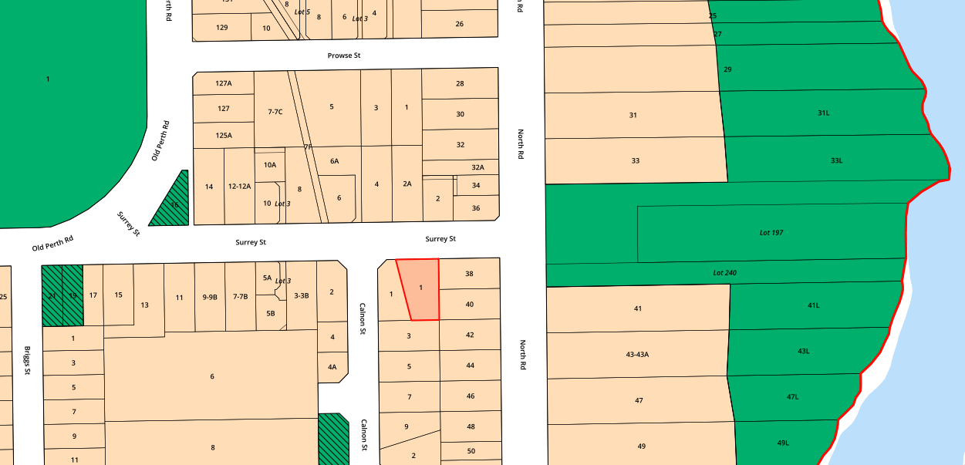

The site comprises two main buildings, being the Pensioner Guard Cottage (constructed circa 1893) and the Residence Building (constructed circa 1952).

The smaller of the buildings on the site is the last remaining ‘Pensioner Guard Cottage’ within the Perth Metropolitan Area; and the oldest remaining building in the Town of Bassendean. The place has a high degree of historic significance due to its association with colonial settlement in Western Australia. At a local level, the significance of the larger Residence Building is also recognized and together, the buildings demonstrate the evolution of residential development following European settlement of the locality.

The site also contains a detached laundry room, three large trees, and simple gardens. A single width concrete driveway provides vehicular access to the site from Surrey Street.

Proposal

The applicant is seeking approval for restoration works and a change of the use of the existing buildings on site. The application is understood to involve the following:

Restoration works

Physical works proposed are limited to the Residence Building and comprise of the following, all of which are consistent with the approved 2007 Conservation Management Plan.

- Demolition of 1952 additions
- Internal works, including demolition of internal walls
- Restoration of roof and the provision of a new verandah

Use of Residence Building

- The use of the Residence Building as an office and storage space, to be occupied by the Perth History Association Inc. (Museum of Perth).
- The Museum of Perth is a not-for-profit organization that chronicles the social, cultural, political and architectural history of Perth. The Museum offers a range of services to promote the preservation and exhibition of collections of cultural historical significance for the benefit community including digitization of records, exhibition design, research and transcription.
- The building is proposed to accommodate up to 20 people at any one time, comprising staff and volunteers. The building will be used between 8am and 6pm, on weekdays only.

Use of Pensioner Guard Cottage

- The continued use of the Pensioner Guard Cottage as a Museum, to operate between 11am and 2pm on weekends supported by two volunteer staff. It is noted that the building has been informally used as a museum since 1993.
- The Pensioner Guard Cottage Museum may accommodate larger groups (such as local school groups) on weekdays, by appointment only.

Communication and Engagement

Public consultation

The application was advertised for a period of 14 days, between 7 September 2023 and 21 September 2023, in the following manner:

- Details of the proposal were made available on the Town’s website; and
- Letters were sent to the owners and occupiers of nearby properties, as below.

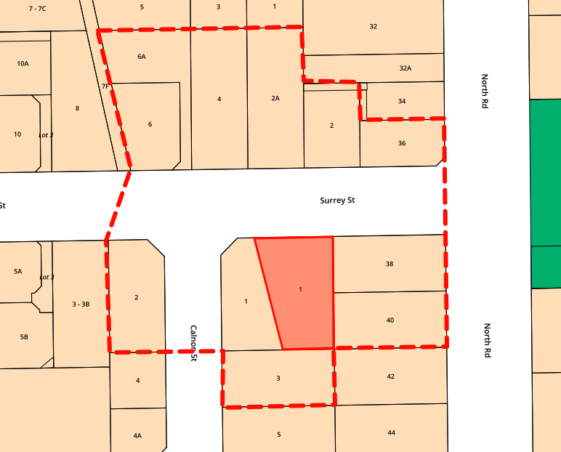

In response, four submissions were received; all objecting to the proposal. A schedule of submissions is attached, with the relevant planning issues being the appropriate classification of the proposed land use (Residence Building), adverse impacts on residential amenity, parking and traffic.

The submissions also provided commentary on matters not relevant to Council’s consideration of the application, including the following:

- The accuracy and reliability of information provided within the application
- Nuisance during demolition/construction works
- Precedence for establishment of similar uses in the locality
- Reduction in property values
- Lack of involvement of local residents in the operations of the landowner.

Agency referrals

The application was referred to the State Heritage Office (SHO), which provided its support for the proposal on behalf of the Heritage Council of Western Australia. In its advice, the SHO states the proposal will “have a major positive benefit on the cultural heritage significance of the Pensioner Guard Cottage”. It also recommended the Town impose conditions on any approval issued requiring further details of conservation works prior and the implementation of an archaeological watching brief to ensure significant material uncovered during the works is dealt with appropriately.

Strategic Implications

Priority Area 6: Providing Visionary Leadership and Making Great Decisions
6.2 Ensure major decision making is informed by community feedback
Priority Area 7: Building Community Identity by Celebrating Culture and Heritage
7.2 Create a community closely connected to its history and heritage

Comment

Local Planning Scheme No. 10 (LPS 10)

The application seeks approval to undertake training and administration activities (historic research, writing, exhibition design, family history research, archiving and record digitization and community workshops and training programs) as well as function as a museum with the storage and display or historical artifacts and collections. The applicant suggests that the activities align with the ‘Community Purpose’ and ‘Exhibition Centre’ land uses under LPS 10, which are defined as follows.

‘Exhibition Centre’ - premises used for the display, or display and sale, of materials of an artistic, cultural or historical nature, and includes a museum or art gallery”.

‘Community Purpose’ - premises designed or adapted primarily for the provision of educational, social or recreational facilities or services by organisations involved in activities for community benefit”.

The subject site is zoned Residential under LPS 10 and, the Community Purpose and Exhibition Centre land uses are listed as “A” and “D” uses, respectively. Such uses are therefore discretionary uses in the residential zone.

It is acknowledged that at least some aspects of the intended use of the Residence Building involves characteristics of both the ‘Community Purpose’ and ‘Office’ land uses; with the latter being defined as “premises used for administration, clerical, technical, professional or other like business activities”. In considering the issue, however, it is noted that the proposed activities do not involve a generic office use (such as a real estate agent or accountant), but rather, bespoke functions and activities by the Museum of Perth (a not-for-profit organisation) that are intrinsically tied to the historic value of the site; being to chronicle the social, cultural, political and architectural history of Perth.

State Planning Policy 3.5 – Historic Heritage Conservation

The policy recognizes that adaptation of heritage buildings for new uses will often be the key to conservation of a heritage place that no longer serves its original function; and in some cases, the conservation and protection of a heritage place may require a change of use to ensure a reasonable beneficial use or return. As outlined in the Conservation Management Plan, extensive repair works are required for the Residence Building to ensure that it does not deteriorate to a point that demolition becomes necessary, nor that restoration becomes unreasonable. The proposed use of the site presents a feasible option to ensure the conservation of the place and ongoing management and maintenance necessary for its preservation.

State Planning Policy 7.3 – Residential Design Codes

Although the proposal does not involve residential development, the site is located within a residential area. The siting and design of buildings on site comply with the Residential Deign Codes and are therefore consistent with the bulk, scale and siting of built form expected on the site.

Local Planning Policy 4 – Heritage and Character

Clause 7.1(a) of the Policy states that “Development shall comply and/or conform to the requirements outlined in any Conservation Management Plan, Heritage Assessment or any other documented review of heritage value.”
The site is subject to the 2007 Conservation Management Plan and the proposed works proposed are consistent with that plan. Although the plan does not stipulate a preferred use of the site; it does emphasis the importance of occupation by an appropriate and viable use as a matter of urgency to ensure its ongoing conservation, maintenance and viability.

Local Planning Policy 8 – Car Parking and End of Trip Facilities

Given the two land uses will operate on different days, the site generates a Policy requirement for 5 car parking bays (on the basis of one bay per four people the buildings are designed to accommodate). The existing concrete driveway can accommodate three cars in a tandem parking arrangement; therefore, the proposal involves a two bay parking shortfall.

In addition, it is noted that in order to comply with the Building Code of Australia, at least one onsite parking bay must be accessible for people with disabilities and meet the relevant Australian Standard (ie. a double-width bay). Given that an ‘accessible’ parking bay cannot be accommodated within the existing single width driveway, an alternative location is required. Whilst it could be constructed within the front setback area, such a location is considered incompatible with the heritage value of the place and would impact on the existing and proposed landscaping. As such, it is recommended that the requisite bay be provided at the rear of the Residence Building.

It is recommended that a condition be imposed requiring the submission of details of a revised onsite carparking arrangement that captures the above. It is noted that compliance with such a condition will reduce the number of onsite bays to one; increasing the parking shortfall to four bays. This variation is supported on the basis that (i) the car parking demand (which is expected to peak during weekday office hours) can easily be accommodated by existing on-street parking bays along Surrey Street and (ii) the Town’s 2019 approval provided for a 15-bay variation to the car parking standards applicable at the time.

Amenity of the Locality

Submissions received in response to advertising suggested that an office, or other non-residential use similar to that proposed, would have an adverse impact on the residential amenity of the locality. The specific concerns included additional traffic, inconvenience caused by increase in on-street parking and increased activity levels in the local area, as discussed below.

Traffic

The increase in traffic expected as a result of the operation of proposed uses is minor and can be easily accommodated by the existing local road network without compromising safety or functionality.

Activity

Submissions noted a general perception that an increase in activity on the site would adversely impact residential amenity, with the Community Purpose use of the Residence Building expected to accommodate a maximum of 20 people during business hours (8am – 6pm on weekdays).

The nature of activities described in the application are considered low-impact and unlikely to result in a level of noise in excess of what could be reasonably expected in a residential setting. Similarly, the continued operation of the Exhibition Centre is considered a low-impact activity of the site, and has not been an issue previously.

Further, Council has previously determined that the use of the site as a museum, community facility and infant health clinic was appropriate, and it is considered that that previous Council-proposal was more potentially impactful that the current application.

The above notwithstanding, it is recommended that the Community Purpose use of the Residence Building be limited to 8.30am – 5.30pm on weekdays. It is further recommended that use of the Pensioner Guard Cottage (Exhibition Centre land use) is broadened so as to be limited to 10.00am – 3.00pm, Saturday and Sunday; thereby allowing a degree of flexibility for that function.

Landscaping

Details of proposed landscaping to be retained, upgraded and installed have not been provided. If the application is approved, it is recommended that a condition be imposed requiring a landscaping plan be submitted to; and approved by the Town.

Conclusion

The proposal represents a viable option for the conservation and ongoing use and management of a place of considerable heritage value. Notwithstanding, there is a need to protect the residential amenity of the locality and conditions of approval are recommended to ensure the uses operate in a manner that is suitable within an established residential area including limitations on activities, hours of operation and capacity.

Statutory Requirements

In accordance with Clause 68(2) of the Planning and Development (Local Planning Schemes) Regulations 2015, Council is required to determine the application by:

(a) granting development approval without conditions; or
(b) granting development approval with conditions; or
(c) refusing to grant development approval.

If the applicant is aggrieved with the decision of the Local Government, a right of appeal may exist in accordance with Part 5 of the Planning and Development Act 2005 with the State Administrative Tribunal.

Financial Considerations

Nil.

Risk Management Implications

Should Council refuse the application, the applicant may appeal to the State Administrative Tribunal. Further, such a refusal would represent a considerable reputational risk in that Council resolved to dispose of the property so as to facilitate the outcome being proposed by the subject application.

Declaration of Conflicts of Interest

All officers involved in the preparation of this report have considered and determined that they do not have a conflict of interest in the matter.

Officer Recommendation – Item 12.3

That Council approves the application for development approval for restoration works and change of the use at Lot 50 (No. 1) Surrey Street, Bassendean, subject to the following conditions:

- The development shall be undertaken in accordance with the approved plans and the recommendations contained within the Conservation Management Plan (Laura Gray, 2007), to the satisfaction of the Town.

- The use of the Residence Building (Community Purpose land use) is limited to 8.30am – 5.30pm, Monday to Friday and to the undertaking of activities directly associated with local heritage, history and culture, as follows.

- Workshops / training
- Research
- Exhibition design
- Writing
- Digitisation or records
- Archiving
- Storage of collections

- The use of the Pensioner Guard Cottage (Exhibition Centre land use) is limited to 10.00am – 3.00pm, Saturday and Sunday. The ‘Exhibition Centre’ is permitted to operate outside the approved hours of operation and/or in excess of the approved site capacity by appointment only and up to a maximum of six times in any calendar year, unless otherwise approved in writing by the Town.

- No more than 20 people are permitted onsite at any one time, unless authorised by the Town prior to the event.

- Prior to the issue of a building permit, the applicant is to submit information regarding the detail and methodology of the following conservation works (including information on materials and finishes), to be approved by the Town, in consultation with the Department of Planning Lands and Heritage:

  - Repair cracks in masonry walls internally and externally
  - Repair door and window lintels
  - Repair ceiling
  - Repair and maintain timber floor
  - Repair service and re-paint windows and door frames
  - Removal of the render from exterior facades, repair the masonry after investigations

All works are to be carried out in accordance with the approved details and methodology, to the satisfaction of the Town.

- Prior to the lodgment of a building permit, a detailed landscape and reticulation plan for the development site and adjoining road verge must be submitted to, and approved by the Town.

- The approved landscape and reticulation plan must be implemented within 90 days of completion of conservation/restoration works and be maintained thereafter to the satisfaction of the Town.

- Prior to the lodgment of a building permit, a schedule detailing the colour and texture of all building materials must be submitted to and approved by the Town of Bassendean in consultation with the Department of Planning, Lands and Heritage. The development must be finished, and thereafter maintained, in accordance with the approved schedule to the satisfaction of the Town.

- Prior to the lodgment of a building permit, a car parking plan must be submitted to, and approved by the Town in consultation with the Department of Planning, Lands and Heritage. The car parking plan shall make provision for one car parking bay designed in accordance with Australian Standard AS 2890.6-2009 Parking Facilities – Off-street parking for people with disabilities.

- Prior to the commencement of use, the approved car parking plan must be implemented. Driveways, parking and maneuvering areas are to be sealed, drained and line marked to the satisfaction of the Town.

- Prior to the commencement of any works on site, an Archeological Watching Brief must be submitted to, and approved by the Town of Bassendean in consultation with the Department of Planning Lands and Heritage. The Archeological Watching Brief must be implemented to the satisfaction of the Town.
- Prior to applying for a Building Permit, storm water disposal plans, details and calculations must be submitted, approved and thereafter implemented and maintained to the satisfaction of the Town.

- All building works to be carried out under this development approval, including footings, are required to be contained within the boundaries of the subject lot.

Voting requirements: Simple Majority
12.4 RFT 05/2023 Provision of Arboricultural Services
12.4 | RFT 05/2023 Provision of Arboricultural Services
File Reference |  | PARE/TENDNG/90
Directorate |  | Corporate Services
Previous Reports |  | Not applicable
Authority/Discretion |  | Executive  The substantial direction setting and oversight role of the Council.
Attachments |  | - CONFIDENTIAL REDACTED - RFT 05 2023 EVALUATION REPORT [12.4.1 - 16 pages]

Purpose

The purpose of this report is for Council to consider the tender received for RFT 05/2023 Arboricultural Services and appoint the contractor.

Background

The Town has a requirement to engage a contractor for arboricultural services. The Town does not have the internal resources to provide the required services and as such requires an appropriate external service provider.

Communication and Engagement

The Request was uploaded to the WALGA (Equotes) VendorPanel Portal on Wednesday, 13 September 2023 and closed on 11:00am (AWST) on Thursday, 28 September 2023.

Strategic Implications

Priority Area 2: Leading Environmental Sustainability
2.6 Support the creation of a more green and shaded Town.

Comment

The Town received a Submission from Beaver Tree Services Aust Pty Ltd, trading as Beaver Tree Services.

The Evaluation Panel comprised of three members with appropriate technical expertise and experience, who assessed the submission in a fair and equitable manner.

Beaver Tree Services met the compliance requirements of the tender and were evaluated against the qualitative criteria and weightings shown in the following table.

QUALITATIVE CRITERIA | WEIGHTING
Capacity | 25%
Demonstrated Experience | 40%
Demonstrated Understanding of the Requirements | 35%

The predetermined qualitative threshold was set at 70% for this tender.

Statutory Requirements

In accordance with clause 11(2) of Part 4 of the Local Government (Functions and General) Regulations 1996, tenders do not have to be publicly invited if the supply of the goods or services is to be obtained through the WALGA Preferred Supplier Program.

Financial Considerations

The costs associated with this contract will be included in the Town of Bassendean’s operational budget for each year of the contract.

Risk Management Implications

Financial Risk
Low

Declaration of Conflicts of Interest

All officers involved in the preparation of this report have considered and determined that they do not have a conflict of interest in the matter.

Officer Recommendation – Item 12.4

That Council accepts the offer submitted by Beaver Tree Services Aust Pty Ltd trading as Beaver Tree Services, to provide Arboricultural Services in accordance with the Terms and Conditions as specified in RFT 05/2023 for a period of three (3) years with an option to extend the Term of the Contract by one (1) year, plus a further option of one (1) Year, at the submitted schedule of rates. The Term of the Contract (including any extensions) will not exceed five (5) years in total.

Voting requirements: Absolute Majority

12.5 Differential Rates Refund Policy Review
12.5 | Differential Rates Refund Policy Review
Property Address |  | N/A
Landowner/Applicant |  | N/A
File Reference |  | RAT&VAL/FEECHAG/3
Directorate |  | Corporate Services
Previous Reports |  | OCM 13/9/21
Authority/Discretion |  | Legislative  Includes adopting local laws, local planning schemes & policies.
Attachments |  | Nil

Purpose

The purpose of this report is for Council to consider a review of the Differential Rates Refund Policy.

Background

Council adopted the Differential Rates Refund Policy in September 2021, and it is now due for review. The objective of the policy was to ensure landowners who develop their land within the specified period were not penalised through the imposition of differential rates.

Proposal

That Council consider whether to allow the policy to expire or amend the policy so that it has future application.

Communication and Engagement

Feedback from Councillors was sought via the CEO Bulletin on 8 September 2023.

One Councillor stated they would like the policy to be made permanent as long as the Town imposes differential rates, for the quantum of rates refund to be increased to up to two years, and for the policy to be communicated to eligible persons.

Strategic Implications

Priority Area 4: Driving Financial Sustainability
4.1 Ensure there is sufficient, effective and sustainable use of assets

Comment

The operation of the current policy is time-specific, in that it applies to differential rates imposed for 2021/22. All required development applications must have been made by 30 June 2022, and the development completed in accordance with the approvals and permits. This was the intended purpose of the policy.

The Town has not received an application for differential rates refund at this stage. A total of 32 properties are potentially eligible for the 2021/22 year.

Council introduced differential rates for the first time as part of the 2021/22 Annual Budget, imposing a premium of 50% of the rate in the dollar for vacant land. Council has continued to impose differential rates as part of the 2022/23 and 2023/24 annual budgets, with a 50% premium on vacant land and a premium for commercial and industrial land. The administration is likely to recommend the continued imposition of differential rates as part of the 2024/25 Annual Budget and the Long-Term Financial Plan.

Given the imposition of differential rates is now well-established at the Town, it is no longer considered necessary to facilitate a potential refund of differential rates on vacant land through the Differential Rates Refund Policy. Further, differential rates on vacant land can be avoided by developing the land. Should Council seek to limit the operation of the policy to differential rates for 2021/22, no action by Council is required, and the policy will remain in existence until the time for the last eligible development application under the policy has expired, at which time the policy will no longer apply.

A copy of the policy will be provided to each eligible landowner by 31 December 2023, to ensure awareness of the policy and the requirements for eligibility for a refund of differential rates, so that they can apply for the rate refund.

However, should Council wish to amend the Differential Rates Refund Policy, it could do so in accordance with the Councillor feedback and/or make other amendments.

Statutory Requirements

Section 6.47 of the Local Government Act 1995 provides that, subject to the Rates and Charges (Rebates and Deferments) Act 1992, a local government may at the time of imposing a rate or service charge or at a later date resolve to waive* a rate or service charge or resolve to grant other concessions in relation to a rate or service charge.
* Absolute majority required.

Financial Considerations

The financial impact of the Differential Rates Refund Policy in its current form is limited to additional rates paid for one year by the owners of vacant land for which all appropriate applications for approvals and permits were made by 30 June 2022, and the development completed in accordance with the issued approvals and permits.

Should Council adopt the draft amended policy, the Town’s rates revenue could be reduced by the equivalent of up to two years of differential rates for each eligible development, although the timing and quantum of the impact is unknown at this stage.

For reference, the total amount to be raised through differential rating of vacant land in the 2023/24 Annual Budget is $85,240.

Risk Management Implications

Financial Risk
Low

The risks associated with either the cessation or continuation of this policy are the financial considerations outlined above.

Declaration of Conflicts of Interest

All officers involved in the preparation of this report have considered and determined that they do not have a conflict of interest in the matter.

Section 5.60A of the Local Government Act 1995 provides that:
‘A person has a financial interest in a matter if it is reasonable to expect that the matter will, if dealt with by the local government, or an employee or committee of the local government or member of the council of the local government, in a particular way, result in a financial gain, loss, benefit or detriment for the person.’

Therefore, Councillors who have vacant land in the Town of Bassendean will have a direct financial interest and should make the relevant declaration.

Officer Recommendation – Item 12.5

That Council:

1. Note this report, thereby allowing the Differential Rates Refund Policy to expire through the effluxion of time.

2. Note that a copy of the Differential Rates Refund Policy will be provided to each of the eligible landowners, by 31 December 2023.

Voting requirements: Simple Majority

12.6 Use of Town Facility - Reserve 21150 (BIC Reserve)
12.6 | Use of Town Facility - Reserve 21150 (BIC Reserve)
Property Address |  | Portion of Reserve 21150 (BIC Reserve)
Landowner/Applicant |  | Crown land
File Reference |  | N/A
Department |  | Community Planning
Previous Reports |  | 23 November 2021
Authority/Discretion |  | Executive  The substantial direction setting and oversight role of the Council.
Attachments |  | Nil

Purpose

The purpose of this report is for Council to consider the future of the existing building and site located on Reserve 21150 (BIC Reserve).

Background

Reserve 21150 (BIC Reserve) is a Crown Reserve managed by the Town, and accommodates a variety of uses and functions. A location plan follows.

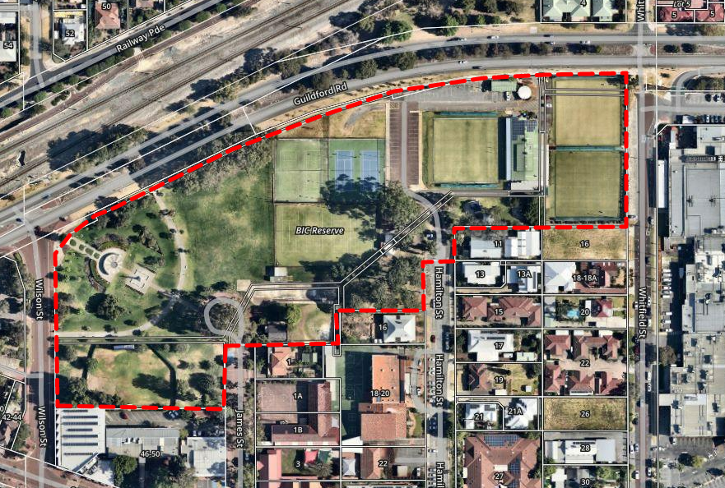
The broader reserve includes a 1,000m² (approx.) area of land that is currently occupied by a Child Health facility, identified in orange as follows.

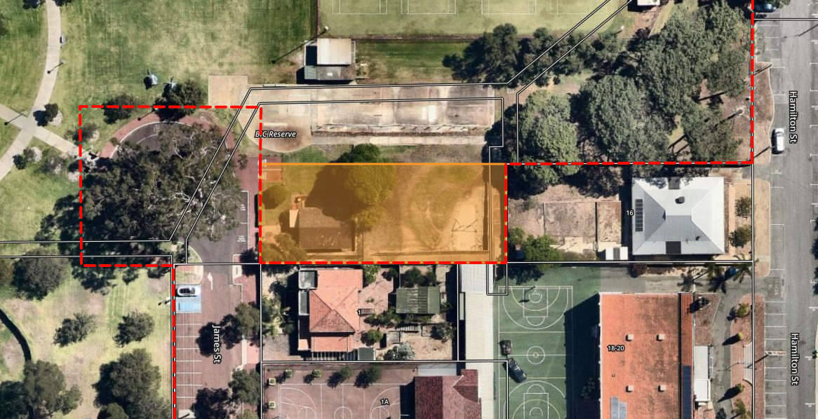

The existing building on site is currently occupied by the Child and Adolescent Health Service of the Department of Health, but that occupation is not supported by a formal lease arrangement.

In November 2021 (and after an 18 month, three-phase, community consultation process), Council adopted the Town Centre Masterplan, which identified the subject portion of the site as being appropriate for 3 - 5 storey development. This aspiration was ultimately supported by draft Local Planning Scheme No. 11 (LPS 11) which proposes that the subject portion of the site be rezoned to District Centre.

Communication and Engagement

As demonstrated by the BassenDream our Future engagement process, the consultation associated with the Town Centre Masterplan and the results of the 2020 and 2022 Catalyse Community Surveys, it is clear that the community strongly supports greater vibrancy and activity within the Bassendean Town Centre.

Town staff have had discussion the Department of Health, advising of the potential that the premises will need to be vacated in the near future and working towards the provision of an alternate facility as part of the Ashfield Community Centre.

Strategic Implications

Priority Area 3: Creating a Vibrant Town and Precincts
3.1 Support the town centre to thrive
3.2 Increase the residential population close to centres and train stations
Priority Area 4: Driving Financial Suitability
4.1 Ensure there is sufficient, effective and sustainable use of assets

Comment

Proposed transition to Ashfield Community Centre

In accordance with the adopted Land Asset Strategy, Council’s strategic intent is for the State Government to redevelop the site to its highest and best use, in accordance with the Town Centre Masterplan. A necessary step in the process is to vacate the subject building. Whilst this requires displacing the Child and Adolescent Health Service, Council is able to consider favorable terms at the Ashfield Community Centre (Colstoun Road, Ashfield) to enable a smooth and cost-effective transition and to ensure Infant and Child Health services continue to be provided to the district. The Town has recently undertaken significant maintenance works at this facility to enable its immediate occupation.

The available space forms the balance of the former Seniors and Disability Services facility that is not otherwise leased by Amana Living. The leasable area comprises seven offices, a meeting room, lunchroom and storage area and is located in very close proximity to Ashfield Railway Station. It is considered to be a superior option for the Department of Health.

Based on the above, it is recommended that Council endorse an approach which requires the subject building to be vacated by 31 December 2024 and authorises the CEO to enter into lease negotiations with the Department of Health that would include a 12-month rent free period (excluding outgoings).

Existing building located on BIC Reserve

Irrespective of Council’s decision on the matter, in the event that the Department of Health continues to use the existing building, it is required to be supported by a formal lease.

Based on the above, the Town will enter into lease negotiations with the Department of Health with a view to having an executed lease as soon as possible.

Statutory Requirements

Disposal (including leasing) of land with a value of greater than $5,000 must be undertaken in accordance with the requirements of Section 3.58 of the Local Government Act 1995, which provides for an auction, public tender or public advertising processes.

Regulation 30(2)(c)(ii) of the Local Government (Functions and General) Regulations 1996 provides that the disposition of land is exempt from those requirements if the
the land is disposed of to “a department, agency, or instrumentality of the Crown in right of the State or the Commonwealth”

Based on the above, the proposed lease is an exempt disposition.

In accordance with the Land Administration Act 1995, the Town is required to obtain the consent of the Minister for Lands to grant a lease of Crown land.

Financial Considerations

Nil. The current occupation of the building does not generate any income.

Risk Management Implications

There is a reputational risk to Council in displacing the Child and Adolescent Health Service, however, that is mitigated by the Town’s continued assistance to the Department of Health in providing an alternative site on favorable terms.

Declaration of Conflicts of Interest

All officers involved in the preparation of this report have considered and determined that they do not have a conflict of interest in the matter.

Officer Recommendation – Item 12.6

That Council:

1. endorses an approach that requires the subject building (current Child Health facility) on BIC Reserve to be vacated by the 31 December 2024.

2. notes that the Town will seek to progress a formal lease with the Department of Health for the use of the Ashfield Community Centre, commencing no later than 1 January 2025. The lease is to include a 12-month rent free period to assist with the relocation of the service.

3. notes that the Town will seek to progress a formal lease with the Department of Health for the use of the subject building (current Child Health facility) on BIC Reserve, commencing as soon as possible and running to no later than 31 December 2024.

Voting requirements: Simple Majority

12.7 Accounts Paid - October 2023
12.7 | Accounts Paid - October 2023
Property Address |  | N/A
Landowner/Applicant |  | N/A
File Reference |  | FINM/CREDTS/4
Directorate |  | Corporate Services
Previous Reports
Authority/Discretion |  | Legislative  Includes adopting local laws, local planning schemes & policies.
Attachments |  | - Accounts Paid - October 2023 [12.7.1 - 12 pages]

Purpose

The purpose of this report is for Council to receive the list of payments for October 2023.

Background

Regulation 13 of the Local Government (Financial Management) Regulations 1996, requires a list of accounts paid by the CEO each month to be presented to Council at the next ordinary meeting of Council after the list is prepared.

Communication and Engagement

Nil.

Strategic Implications

Priority Area 4: Driving Financial Suitability
4.1 Ensure there is sufficient, effective and sustainable use of assets
4.3 Support the local economy

Comment

Payments made during October 2023 are presented to Council, showing the date, payee, amount and description in respect of each payment for goods and services received.

Statutory Requirements

Local Government (Financial Management) Regulations 1996

Financial Considerations

All payments are authorised prior to disbursement in accordance with the Town’s Purchasing Policy, Procurement Guidelines and allocated budgets.

Risk Management Implications

Financial Risk
Low

The Town has adequate controls in place to mitigate external and internal risks in accounts payable.

As an extra measure, the Town uses EftSure to independently check bank account details of suppliers paid by the Town.

Declaration of Conflicts of Interest

All officers involved in the preparation of this report have considered and determined that they do not have a conflict of interest in the matter.

Officer Recommendation – Item 12.7

That Council receives the list of payments for October 2023.

Voting requirements: Simple Majority

12.8 Proposed Carport - 104 (Lot 174) Ivanhoe Street, Eden Hill
12.8 | Proposed Carport - 104 (Lot 174) Ivanhoe Street, Eden Hill
Property Address |  | 104 (Lot 174) Ivanhoe Street, Eden Hill
Landowner/Applicant |  | Landowner: Lee Machin and Joanne Hillier  Applicant: Engineering on Demand
File Reference |  | 2023-102
Directorate |  | Community Planning
Previous Reports
Authority/Discretion |  | Quasi-Judicial  When the Council determines an application/matter that directly affects a person’s right and interests. The judicial character arises from the obligation to abide by the principles of natural justice. Examples of Quasi-Judicial authority include town planning applications, building licences, applications for other permits/licences.
Attachments |  | - Development Application Plans [12.8.1 - 3 pages]

Purpose

The purpose of this report is for Council to consider an application for development approval for a carport at 104 (Lot 174) Ivanhoe Street, Eden Hill.

The matter is being referred to Council for determination at the request of the landowner and applicant.

Background

Site History

On 2 March 2023, the Town received an application for development approval for a proposed flat roof carport. Following the Town's request for further information and raising concerns relating to non-compliance with State Planning Policy 7.3 – Residential Design Codes (R-Codes) and Local Planning Policy No. 12 – Residential Development and Fences (LPP 12), on 28 June 2023, the proponent elected to cancel the application.

Following the cancellation of the application, the landowner and the applicant further liaised with the Town to discuss the options in relation to the proposal; with the Town advising of the following options:

- Lodge a new application which better reflects the requirements of the R-Codes and LPP 12.
- Lodge the application as previously and have the matter considered on its merits, which may not be supported by Town staff. If they elected this option, it was open to request that the application is determined by Council.

On 14 October 2023, the proponent submitted a new application for development approval and requested the application be determined by Council. The plans which have been submitted are the same as the previous development application which was cancelled by the proponent.

Site Description and Planning Framework

The subject site is a 706m² lot, zoned Residential R20/R30 under Local Planning Scheme No. 10 (LPS 10). The site contains an existing single house. A location plan follows.
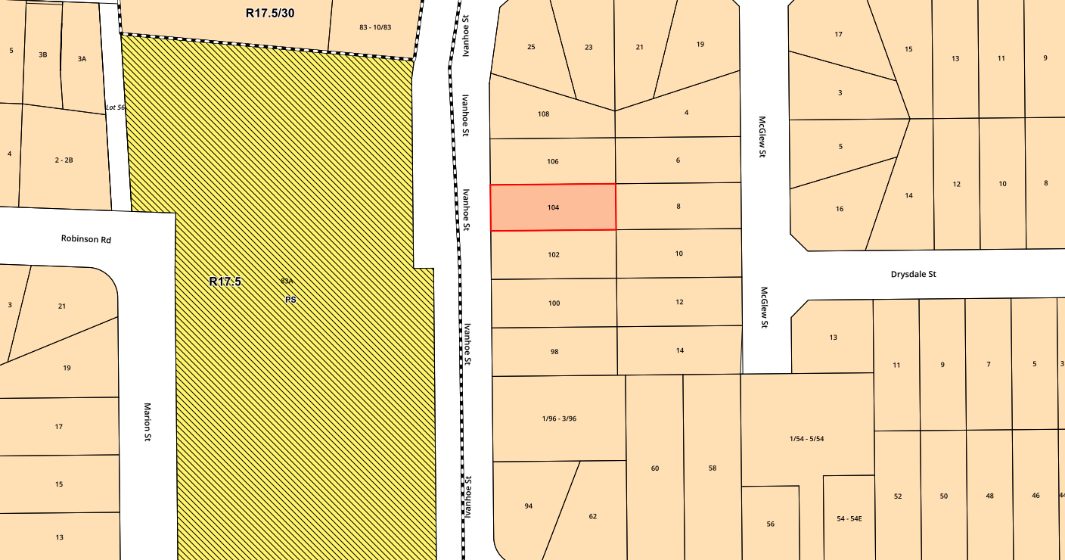

Proposal

The proposal involves the following:

- The construction of a 6.9m x 6.2m flat-roofed carport, located to the northern side of the lot, within the primary street setback area.
- The carport is 2.4m in height, and is setback from the 1m from the northern lot boundary and 0.6m from the primary street boundary.
- The carport will be constructed with metal columns and sheet (Colorbond ‘Heritage Red’) metal roofing.
- The carport will facilitate vehicles to be parked parallel to Ivanhoe Street.

Communication and Engagement

The development application was not referred to adjoining landowners for comment on the basis that there was no specific impact on abutting (neighbouring) sites and the property directly opposite the site is a school.

Strategic Implications

Priority Area 1: Strengthening and Connecting our Community
1.1 Fostering a culture of collaboration and trust between the organisation and community

Comment

Local Planning Scheme No. 10 (LPS 10)

The subject site is zoned Residential R20/30 under LPS 10. The proposed carport is incidental to the existing Single House, which is a “P” use within the Residential zone, meaning the use is permitted by the Scheme providing the use complies with the relevant development standards and the requirements of the Scheme.

State Planning Policy 7.3 – Residential Design Codes Volume 1 and Local Planning Policy No. 12 – Residential Development and Fences (LPP 12)

The R-codes include ‘deemed-to-comply’ Criteria (prefixed by “C”) and Design Principles (prefixed by “P”). Applications not complying with the deemed-to-comply criteria can be assessed against relevant design principles. LPP 12 serves to provide alternative ‘deemed-to-comply’ criteria. The following table outlines the aspects of the proposal that do not meet the either of the ‘deemed-to-comply’ criteria and provides an assessment against the relevant design principles.

R-Code and Policy Provision | Assessment/Comment
5.2.1 – Setback of garages and carports
C1.2 R-Codes Deemed to Comply  Carports set back in accordance with the primary street setback requirements of clause 5.1.2 C2.1 (i) except that the setback may be reduced by up to 50 per cent of the minimum setback stated in Table 1 where:  i. the width of the carport does not exceed 60 per cent of the frontage;  ii. the construction allows an unobstructed view between the dwelling and the street, right-of-way or equivalent; and  iii. the carport roof pitch, colours and materials are compatible with the dwelling. | Clause 5.1.2 C2.1 (i) requires a 6m setback, which can be reduced to 3m in some circumstances. The proposal involves a 0.6m setback.  iii. As viewed from the street, the existing redbrick dwelling has a terracotta tile gable roof. The application proposes a flat roof carport, constructed of metal sheeting. The roof pitch is not considered compatible with the dwelling.
C1.2 LPP 12 Alternative Deemed to Comply  Carports set back so as to be behind the street setback and/or no closer to the street that the existing dwelling on the lot, unless it complies with all of the following:  iii. the carport roof pitch, colours and material are the same as the dwelling; and  iv. support columns shall be the same brick as the dwelling.  v. any metal deck carport is only the replacement of an existing, approved metal deck carport structure, with the new structure the same size or smaller than the existing. | The carport is located within the primary street setback area and forward of the existing dwelling.  iii. As viewed from the street, the existing redbrick dwelling has a terracotta tile gable roof. The application proposes a flat roof carport, constructed of metal sheeting. The roof pitch and materials are not the same as the dwelling.  iv. The carport is proposed to have metal support columns.  v. The proposal is for a new flat roof carport that does not replace any existing one.
P1.2 Carports and garages setback to maintain clear sight lines along the street, to not obstruct any views of the dwellings from the street and vice versa, and designed to contribute positively to streetscapes and the appearance of dwellings.  P1.2 Garages and/or carports set back to ensure any vehicle parking on a driveway does not impede on any existing or planned adjoining pedestrian, cycle or dual-use path. | In considering the design principles, the following is relevant:  - The existing streetscape in the local area is characterised by dwellings with compliant primary street setbacks, with a majority of the street setback area for each lot being landscaped. The Town’s Built Form and Character Study provides guidance on identified characteristics of buildings and places which are valued and should be reflected in future development. Relevant design objectives within the Study are “maximising areas of soft landscaping and discouraging large areas of hard landscaping” and “ensuring building materials and design create a cohesive streetscape.” The proposed development fails to achieve those design objectives in that it does not limit the dominance of hard landscaped surfaces and provides for insufficient soft landscaping, with more than 50% of the front setback area to be utilised for vehicle access. The development fails to utilise building materials, design and colour that are cohesive to the existing dwelling and therefore will have a negative impact on the amenity of the streetscape.  - There is a carport located forward of the primary street setback in the nearby No. 96 Ivanhoe Street, Eden Hill, however, that form of the development would comply with the requirements of LPP 12.  - Due to its pitch, colours and materials, the flat roof carport will appear disjointed from the dwelling and be visually unappealing. Given the prominent location of the proposed structure, being well forward of the existing dwelling, it will not positively contribute to or enhance the amenity of the streetscape or the existing dwelling.  - Whilst the proposed material (being Colorbond Heritage Red sheeting) does not match the terracotta tiled roof of the existing dwelling, it is considered broadly acceptable.  Based on the above, it is considered that the proposal does not meet the relevant Design Principle.
5.3.2 - Landscaping
C2.2 Landscaping of single houses, grouped dwellings and multiple dwellings to include the following:  (ii) landscaping of the street setback area, with not more than 50 per cent of this area to consist of impervious surfaces. | Due to the positioning of the carport, more than 80 per cent of the primary street setback area will consist of impervious surface used for vehicle manoeuvring.
P2 Landscaping of open spaces that:  • contribute to the appearance and amenity of the development for the residents;  • contribute to the streetscape;  • enhance security and safety for residents;  • contribute to positive local microclimates, including provision of shade and solar access as appropriate; and  • retains existing trees and/or provides new trees to maintain and enhance the tree canopy and local sense of place. | In considering the principles, the following is relevant:  - the existing streetscape is characterised by significant portions of landscaping forward of dwellings.  - The lack of landscaping is a function of the proposed vehicle manoeuvring design.  - the development will be inconsistent with, and fails to contribute positively to, the existing streetscape.  Based on the above, it is considered that the proposal does not meet the relevant Design Principles.

Based on the above, the proposal is considered to be unacceptable and it is therefore recommended that the application be refused.

Alternatively, it is open to Council to consider the that application meets the relevant design principles and to subsequently approve the application.

Statutory Requirements

In accordance with Clause 68(2) of Schedule 2 (Deemed Provisions) the Planning and Development (Local Planning Schemes) Regulations 2015, Council is required to determine the application by:

“(a) granting development approval without conditions; or
(b) granting development approval with conditions; or
(c) refusing to grant development approval.”

Financial Considerations

Nil.

Risk Management Implications

Should Council refuse the proposal, the applicant may seek to appeal to the State Administrative Tribunal.

Declaration of Conflicts of Interest

All officers involved in the preparation of this report have considered and determined that they do not have a conflict of interest in the matter.

Officer Recommendation – Item 12.8

That Council refuses the application for development approval for a carport at 104 (Lot 174) Ivanhoe Street, Eden Hill, for the following reason:

- The proposal does not comply with the setback and landscaping requirements of either State Planning Policy 7.3 – Volume 1 – Residential Design Codes or Local Planning Policy No. 12 – Residential Development and Fences and does not meet the associated design principles as it is inconsistent with the existing and desired streetscape character due to its the proposed material, roof pitch and dominance of hard spaces, and, as a result, would detrimentally impact the amenity of the locality.

Voting requirements: Simple Majority

12.9 Memorandum of Understanding with Swan Districts Football Club
12.9 | {Memorandum of Understanding with Swan Districts Football Club}
Property Address |  | N/A
Landowner/Applicant |  | N/A
File Reference |  | LEGL/AGMT/8
Directorate |  | Office of the CEO
Previous Reports |  | N/A
Authority/Discretion |  | Information  For the Council/Committee to note.
Attachments |  | - CONFIDENTIAL REDACTED - To B and SDFC Mo U 12.10.23 [12.9.1 - 6 pages]

Purpose

The purpose of this report is for Council to note the negotiations and ultimate Memorandum of Understanding (MOU) entered into between the Town of Bassendean and the Swan Districts Football Club (SDFC) to clearly identify the general terms and conditions of each party for a redevelopment of the SDFC.

Background

At the Ordinary Council Meeting dated 22 August 2023 Council resolved for the
CEO to formally enter into negotiations with Swan Districts Football Club to develop an MOU, or such other document that is deemed appropriate, to assist in scoping and delivery of agreed terms for the potential redevelopment of the SDFC.

This report addresses part two (2) of the resolution that a report to be provided to Council within 3 months.

A confidential copy of the MOU is attached.

Communication and Engagement

- Meeting with representatives of Swan Districts Football Club

Strategic Implications

Priority Area 3: Creating a Vibrant Town and Precincts
3.1 Support the town centre to thrive

Comment

As advised via the CEO Bulletin dated 13 October 2023, an MOU was prepared and duly executed by the Mayor and CEO of the Town of Bassendean and President and CEO of the Swan Districts Football Club in early October 2023 with the final signature effected on 11 October 2023.

Statutory Requirements

N/A

Financial Considerations

In considering any future financial impact of this MOU, Council is to have due regard to the Council Plan and Long Term Financial Plan.

Risk Management Implications

Financial Risk
Low

Declaration of Conflicts of Interest

All officers involved in the preparation of this report have considered and determined that they do not have a conflict of interest in the matter.

Officer Recommendation – Item 12.9

That Council

Note the execution of a Memorandum of Understanding (MOU) between the Town of Bassendean (TOB) and the Swan Districts Football Club (SDFC).

Voting requirements: Simple Majority

12.10 Draft amended Local Planning Policy 2 - Sustainable Development
12.10 | Draft amended Local Planning Policy 2 - Sustainable Development
Property Address |  | N/A
Landowner/Applicant |  | N/A
File Reference |  | TBA
Department |  | Community Planning
Previous Reports |  | 24 May 2022  27 June 2023
Authority/Discretion |  | Legislative  Includes adopting local laws, town planning schemes & policies.
Attachments |  | - Existing Local Planning Policy 2 - Sustainable Development [12.10.1 - 4 pages]  - Draft amended Local Planning Policy 2 - Sustainable Development [12.10.2 - 5 pages]

Purpose

The purpose of this report is for Council to consider a draft amended Local Planning Policy 2 – Sustainable Development (LPP 2).

Background

In May 2022, Council resolved to adopt LPP 2; effectively replacing the previous Local Planning Policies 2 and 3. The replacement policy was intended to apply only to lots which had been applied a split residential coding under Local Planning Scheme No. 10 (LPS 10), however, Council resolved to apply the policy to all residential development, with the exception of (i) minor alterations and additions that do not impact the energy efficiency of an existing dwelling and (ii) proposals involving multiple dwellings at or above Residential R40.

In June 2023, Council resolved to adopt minor amendments to LPP 2, so as to respond to impending changes to Volume 1 the R-Codes, as follows.

- The introduction of Part C (Medium Density), which will apply to all single houses and grouped dwellings in areas coded R30 and above, and multiple dwellings in areas coded R30 to R60.

- Amendment of Part B (Low Density) so as to only apply to residential development in areas coded up to and including R25.

In August 2023, the Minister for Planning advised that the above changes would not be made to the planning framework. As such, it is appropriate to revisit the policy at this time.

Communication and Engagement

Nil.

Strategic Implications

Priority Area 2: Leading Environmental Sustainability
2.6 Support the creation of a more green and shaded Town
Priority Area 6: Providing Visionary Leadership and Making Great Decisions
6.3 Ensure operational activities reflect the strategic focus of Council

Comment

The proposed amendments to the Policy are relatively minor, as follows:

- Referencing the operative local planning scheme rather than Local Planning Scheme No. 10 specifically.
- Reinstatement of Attachment A (Credit Point Checklist) on the basis that State Planning Policy 7.3 – Residential Design Codes – Volume 1 (Part C) – Medium Density was not introduced as planned.

Statutory Requirements

Clause 5(2) of Schedule 2 (Deemed Provisions) of the Planning and Development (Local Planning Schemes) Regulations 2015 states that the “the local government may make an amendment to a local planning policy without advertising the amendment if, in the opinion of the local government, the amendment is a minor amendment.”

Given the proposed changes to the Policy are relatively minor, it is recommended that the draft amended policy be adopted without undertaking any consultation. It is open to Council however to consider that the changes are not minor, in which case, Council is able to adopt the draft policy for the purposes of public consultation.

Financial Considerations

Nil.

Risk Management Implications

No Risks Identified

Declaration of Conflicts of Interest

All officers involved in the preparation of this report have considered and determined that they do not have a conflict of interest in the matter.

Officer Recommendation – Item 12.10

That Council, pursuant to Clause 5(2) of Schedule 2 (Deemed Provisions) of the Planning and Development (Local Planning Schemes) Regulations 2015, provisionally adopts draft amended Local Planning Policy 2 – Sustainable Development.

Voting requirements: Absolute Majority

12.11 Contract Variation - RFT 04/2023 Supply and Installation of a Bore at Ashfield Reserve
9.13 | Contract Variation – RFT 04/2023 Supply and Installation of a Bore at Ashfield Reserve
Property Address |  | N/A
Landowner/Applicant |  | N/A
File Reference |  | PARE/TENDNG/89
Directorate |  | Corporate Services
Previous Reports |  | Special Council Meeting 11 July 2023
Authority/Discretion |  | Executive  The substantial direction setting and oversight role of the Council.
Attachments |  | N/A

Purpose

The purpose of this report is for Council to consider a variation to contract 04/2023 Supply and Installation of a Bore at Ashfield Reserve.

Background

Council resolved to approve Tender 04/2023 Supply and Installation of a Bore at Ashfield Reserve at a Special Council Meeting on 11 July 2023, appointing Western Irrigation Pty Ltd to undertake the contract.

During the tender preparation stage, it was identified that further inspection and testing of the switchboard at Ashfield Reserve was required. Accordingly, a line item for a switchboard upgrade was included (as a provisional sum) in the tender price schedule and that item was priced at $29,500 by the contractor in its tender submission.

Since award of the contract and commencement of the works, the contractor has advised that the switchboard contains outdated componentry which is unlikely to be compliant with the WA Electrical Requirements issued by Director of Energy Safety on 1 August 2023, and has recommended that the switchboard be upgraded.

Strategic Implications

Priority Area 4: Driving Financial Sustainability
4.1 Ensure there is sufficient, effective and sustainable use of assets.
4.2 Ensure community facilities are accessible to and well utilized by a diverse range of community members.

Comment

This is the first contract variation since the commencement of this contract. The scope of works for this contract will marginally increase due to this variation but will not have any effect on the Contract Term.

Statutory Requirements

A Local Government may vary a contract for the supply of goods or services if the variation is necessary for the goods or services to be supplied and does not change the scope of the contract, pursuant to Regulation 21A of the Local Government (Functions and General) Regulations.

While the CEO has delegated authority to approve minor contract variations, Council is required to approve any proposed variation for more than 5% of the original contract price.

Section 6.8 of the Local Government Act 1995 provides that:

- A local government is not to incur expenditure from its municipal fund for an additional purpose except where the expenditure —
  - is incurred in a financial year before the adoption of the annual budget by the local government; or
  - is authorised in advance by resolution*; or
  - is authorised in advance by the mayor or president in an emergency.
* Absolute majority required.

(1a) In subsection (1) —

additional purpose means a purpose for which no expenditure estimate is included in the local government’s annual budget.

Financial Considerations

The variation sought will increase the cost of the contact by $29,500, equating to 7.78% of the original contract price.

The additional budget is proposed to be obtained from the Asset Enhancement Reserve, with the intention of replenishing that Reserve at the mid-year budget review.

Risk Management Implications

Financial Risk
Low

While the financial risk is low, there is a moderate risk of periodic interruption to power supply, which could be prolonged due to the age of the componentry and the difficulty sourcing replacement components and servicing the unit, if the switchboard is not upgraded.

Declaration of Conflicts of Interest

All officers involved in the preparation of this report have considered and determined that they do not have a conflict of interest in the matter.

Officer Recommendation – Item 12.11

That Council:

1. Approves a variation to contract 04/2023 Supply and Installation of a Bore at Ashfield Reserve to upgrade the existing switchboard at Ashfield Reserve at a cost of $29,500.

2. Authorises the use of $29,500 from the Asset Enhancement Reserve for the purpose of the variation of contract to upgrade the existing switchboard at Ashfield Reserve.

Voting requirements: 1: Simple Majority; 2: Absolute Majority

12.12 Bassendean Local Emergency Management Committee Meeting - 14 November 2023
12.12 | Bassendean Local Emergency Management Committee Meeting - 14 November 2023
File Reference |  | GOVN/CCLMEET/12
Department |  | Community Planning
Previous Reports |  | Nil.
Authority/Discretion |  | Executive  The substantial direction setting and oversight role of the Council.
Attachments |  | - BLEMC Minutes - 14 November 2023 [12.12.1 - 5 pages]

Purpose

The purpose of this report is for Council to receive the minutes of the Bassendean Local Emergency Management Committee (BLEMC) Meeting held on 14 November 2023.

Strategic Implications

Priority Area 6: Providing Visionary Leadership and Making Great Decisions
6.3 Ensure operational activities reflect the strategic focus of Council

Comment

The Committee discussed the following items at the meeting.

- Local Emergency Management Arrangements
- 2023/24 Fire Season Preparedness
- Agency Member Reports (Round Table)

Statutory Requirements

Under sections 38 - 40 of the Emergency Management Act 2005, local governments are required to establish and carry out the functions of a Local Emergency Management Committee, which includes coordinating the development and submission of documents in accordance with legislative and policy requirements including an Annual Report, Annual Business Plan and maintenance of Local Emergency Management Arrangements.

Financial Considerations

Nil.

Risk Management Implications

Nil.

Declaration of Conflicts of Interest

All officers involved in the preparation of this report have considered and determined that they do not have a conflict of interest in the matter.

Committee Recommendation – Item 12.12

That Council receives the minutes of the Bassendean Local Emergency Management Committee meeting of 14 November 2023.

Voting requirements: Simple Majority

13 Motions of which Previous Notice has been given

14 Announcements of Notices of Motion for the next meeting
15 Urgent Business

16 Confidential Business

Officer Recommendation

That the following matters be considered with members of the public excluded from the Chamber under Clause 5.23 (2) of the Local Government Act 1995, in the list below;

- 16.2 Interim FOGO Supply agreement
- 16.3 Appointment of members to the Audit and Governance Committee 2023-2025

17 Closure

The next Briefing Session will be held on Tuesday 12 December 2023 commencing at 6pm.

The next Ordinary Council meeting will be held on 19 December 2023 commencing at 6pm.

